**Solitaire Prototype**

**Starting Game**

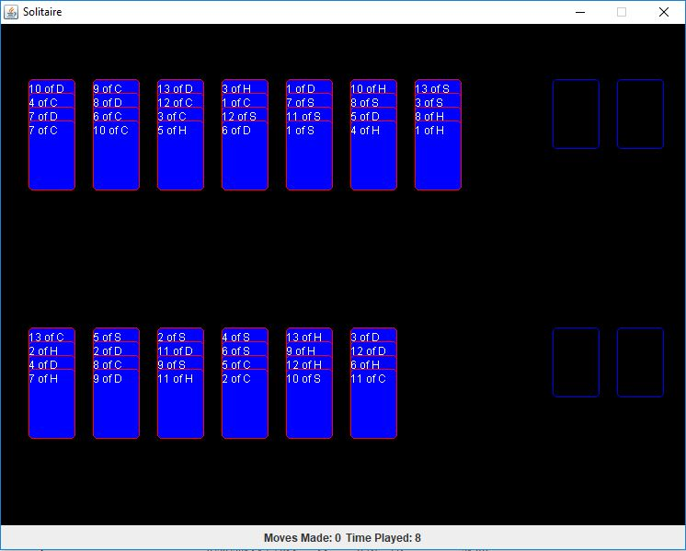

When the application is started the game generates 52 cards, shuffles them, and fills the 13 tableau slots with 4 cards each. Kings will be placed at the bottom of a randomly chosen slot.

Cards at the moment are just displayed as blue rectangles with white text stating what card it is. The final version of the game will have the traditional card images that we’re all used to.

Foundation slots are the empty slots to the right. They need to be filled A-K to complete the game.

The timer begins immediately and reminds you how slow you are at playing solitaire.

**Selecting a Card**

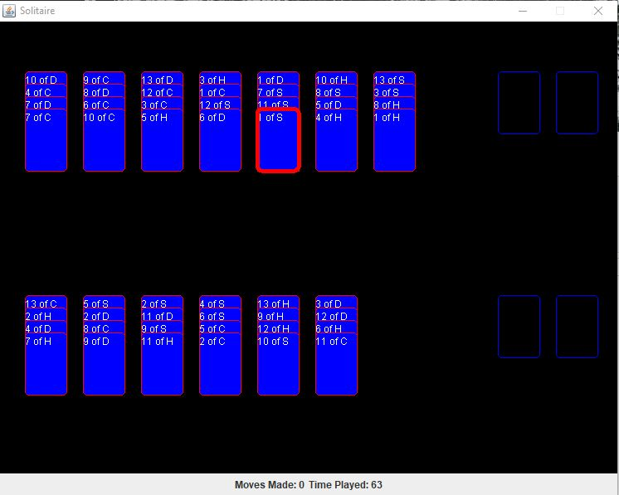

The player can select a card by hovering over it and clicking a mouse button. The card selected is highlighted with a red box. Clicking another card when you have a card selected will let you try to move the first card onto the second. You can also select slots – it only works if its empty though and it also gets highlighted.

**Moving Card into a Foundation Slot**

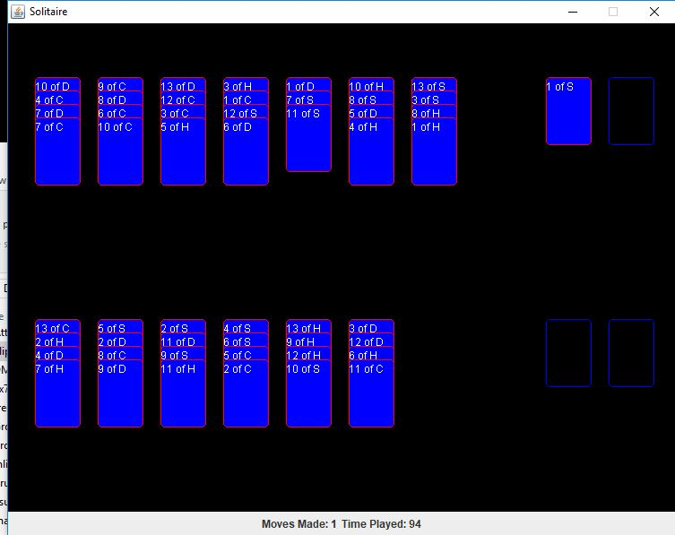

Foundation slots must start with an ace. Other cards cannot be placed onto empty slots. In general, to move cards onto a foundation slot first it must be an ace, and then proceeding cards must be of the same suit and of rank 1 higher than the one it will cover. A move counter will track each successful move that was made.

**Moving Card into a Tableau Slot**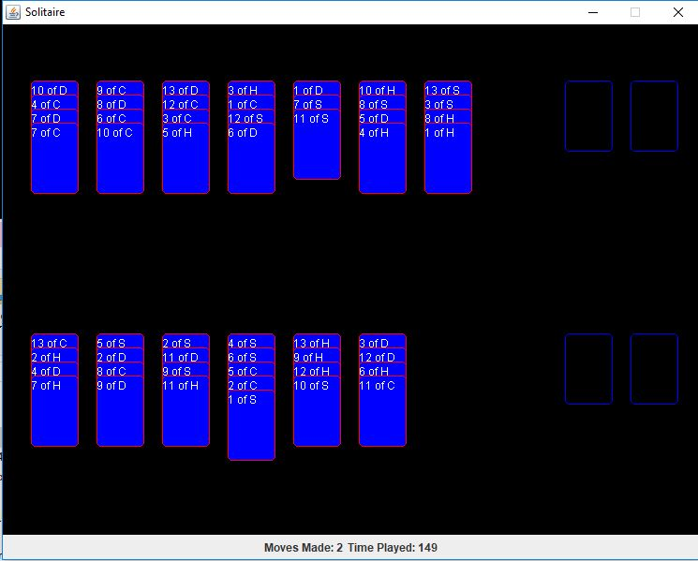

Tableau slots will be where you do most of the work. Suit does not matter and rank must be 1 less than the card it will cover. You should try to uncover lower rank cards first and get the foundation slots filled up quickly so you have more freedom to move cards around on tableau slots. Hope that you don’t have an ace under a queen!

**Selecting a Slot**

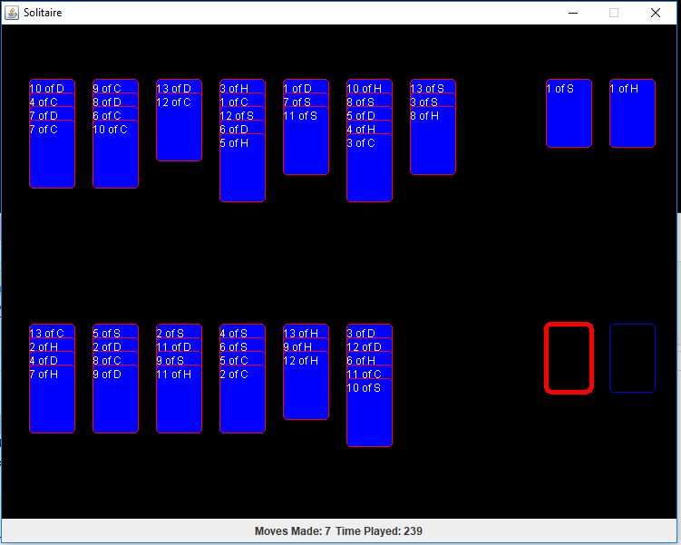

**Continuing to play..**

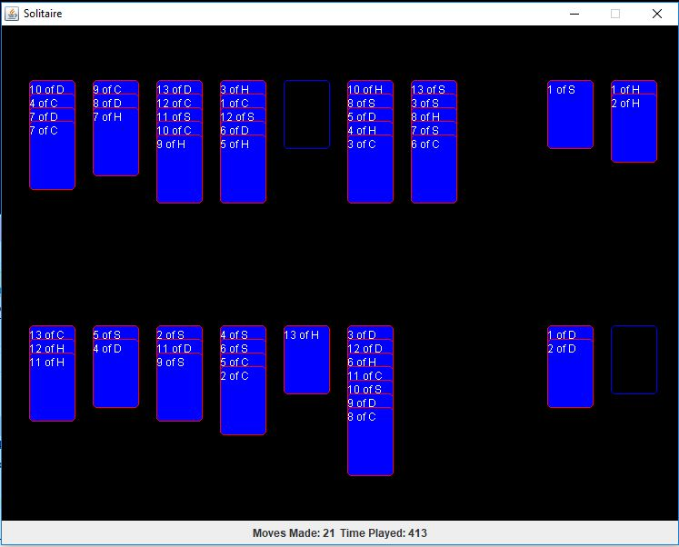

Eventually you get into a messy situation like this. This is when it starts to get fun.

Features/Use Cases Not Seen Here to be expected in final Version:

* A bigger display for the game screen
* Images for cards and the game screen
* Tweaked Interaction with the UI
* A menu which will allow the player to start a game, or undo a move.
* Something to happen when the game is complete.